Lifting
The Region 3 Division 4 Regional Meet will be on

Thursday, March 7th, 2024 at Arp High School, Arp TX

  - Begins at 3:45 PM in the Gym (Map attached)

Platforms
  - There will be 4 platforms, and no flights.

Platform 1 | Platform 2 | Platform 3
114, 123,132 | 148,165,181 | 198,220,242
Platform 4
275,308,SHW

Bring with you:
  - Eligibility Form - Signed by your Principal or Superintendent
  - Scholarship Application (Optional) For senior lifters who would like to be considered for a
$1,000 scholarship to help with college expenses.
  - Check for $35.00 per lifter payable to: Harmony ISD Athletics*
*Your school becomes responsible for your lifter(s) entry fee at 4:00 p.m., Monday, February 29th. Please notify me on or before the deadline if your lifters can’t compete or you will be responsible for their entry fee.
*No payment is necessary for alternates.

Alternates
  - If you have lifters ranked in the top 20, bring them with you as there may be no-shows or lifters who do not make weight.

Weigh In
  - Wednesday, March 6th - early weigh in: 5:00 to 6:30 P.M.
  - Thursday, March 7th - afternoon weigh in: 2:00 to 3:30 PM.

Coaches / Judges Meeting
  - 3:15

Admission
  - $5.00 (cash only)

T-shirts
  - Will be available

Supper
  - There will be supper served for the coaches.
  - Meals for the athletes: Please notify me by e-mail at wilbanksd@harmonyisd.net how many meals you will need. The cost will be $8.00 each. Make checks for athlete’s
meals payable to Arp Athletic Booster Club. Please do not combine Entry/Meal check.

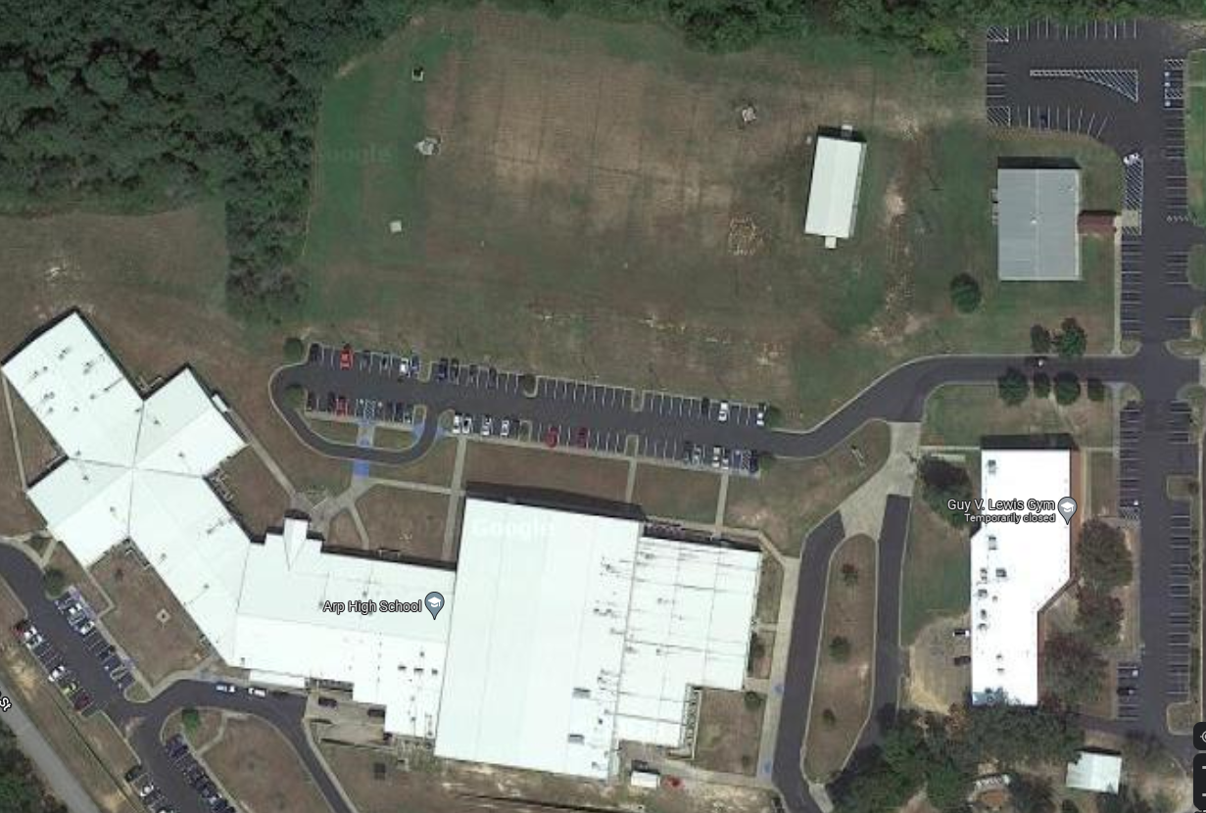
.
Spectator Entrance >>>>
Gym Entrance >>>
Bus/Van Parking >>>>

